Web :

How Does the Internet Actually Work?

* Client computer 🡪 server
* Sending request

Client computer 🡪 ISPs 🡪 DNS (like phone book)

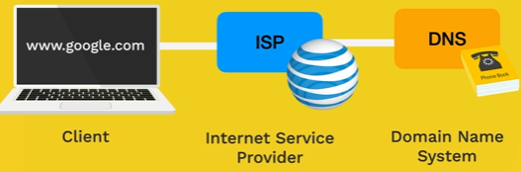

* Response Back

Client computer 🡨 ISPs 🡨 DNS (like phone book)

Every computer has IP addresses

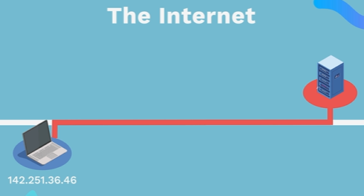

Speed of light (7.6 orbit per second at surface)

How Do Websites Actually Work?

* Website = html +CSS+ JS
* Html is responsible for the content on the website
* CSS is responsible for design on the website.
* JS For logic

HTML (Hyper Text Markup Language)

Hyper link or Hyper Text 🡪 text link to other pages.

Markup Language 🡪 the quotes

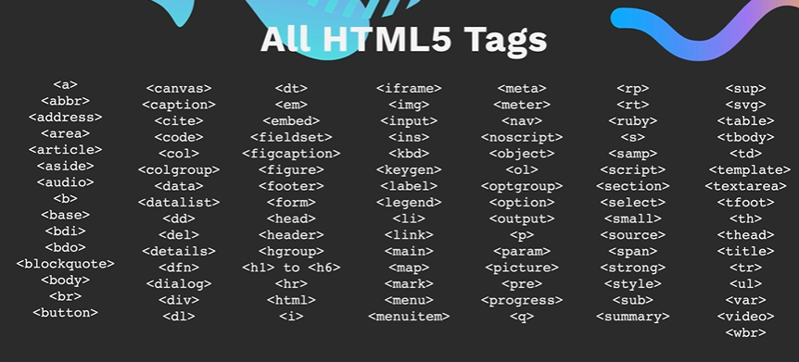

D/b tag and element:

HTML elements are used to describe the structure of

the page

<h1> and< /h1> both are tag

But <h1> lorem</h1 > this complete tag knows as element.

Be carful

* H1 only one used in section or page
* Don’t move directly from h1 to h3 during using title and subtitle

<h1> title </h1>

<h2> Subtitle </h2>

* <h1> to <h6>
* <p>
* Self-closing tags (<br/>, <hr/>)
* Don’t <p> paragraph1 <br> paragraph2 </br> </p>
* Do <p> paragraph2 </p> <p> paragraph 2 </p>
* Unorder list <ul></ul>
* Order list <ol></ol>
* Define list <dl><dt>name which we explain </dt> <dd>explanation </dd></dl>
* List item <li></li>
* Nesting and indentation

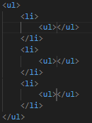

nesting with indentation is so much important to understanding the code.

Nesting of list means list inside list. indentation help us to identify any error in the code.

* Anchor Element <a></a>
* Element has some attribute and attribute has some ex (href, draggable).
* <a href=” mailto: ali01edc@gmail.com”>
* Image element <img src=”” alt=””>
* Online pic links
  + - * [www.istockphoto.com](http://www.istockphoto.com)
      * [www.istockphoto.com](http://www.istockphoto.com)
      * [www.gettyimages.com](http://www.gettyimages.com)
      * [www.veer.com](http://www.veer.com)
      * [www.sxc.hu](http://www.sxc.hu)
* Inline element: Some elements will always appear to continue on the same line as their neighboring elements. These are known as inline elements.

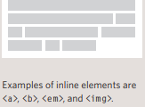

* Block- line element: Some elements will always appear to start on a new line in the browser window. These are known as block level elements.

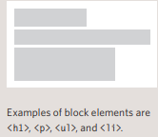

* Div element: element allows you to group a set of elements together in one block-level box.
* Iframe: is a window that used to open other website pages in the web page like using map.
* 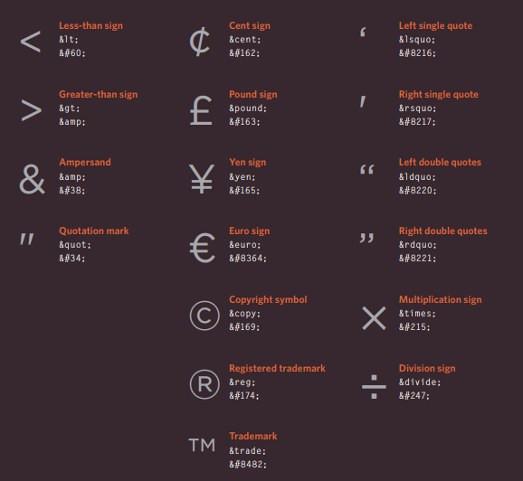
* Two types of File path absolute and relative path
* Webpage +webpages
* Html boilerplate 
 